Data Flow Diagram Architectural Visuals
Date | 22 September 2026
Team ID
Project Name | Online Complaint Registration
Maximum Marks | 4 Marks

1. DFD Level 0: Context Diagram Diagrammatic Flow
The Context Diagram represents the overall scope of the Online Complaint Registration System, showing the major interactions, inputs, and outputs between the system and its external entities such as Users, Agents, and Administrators.
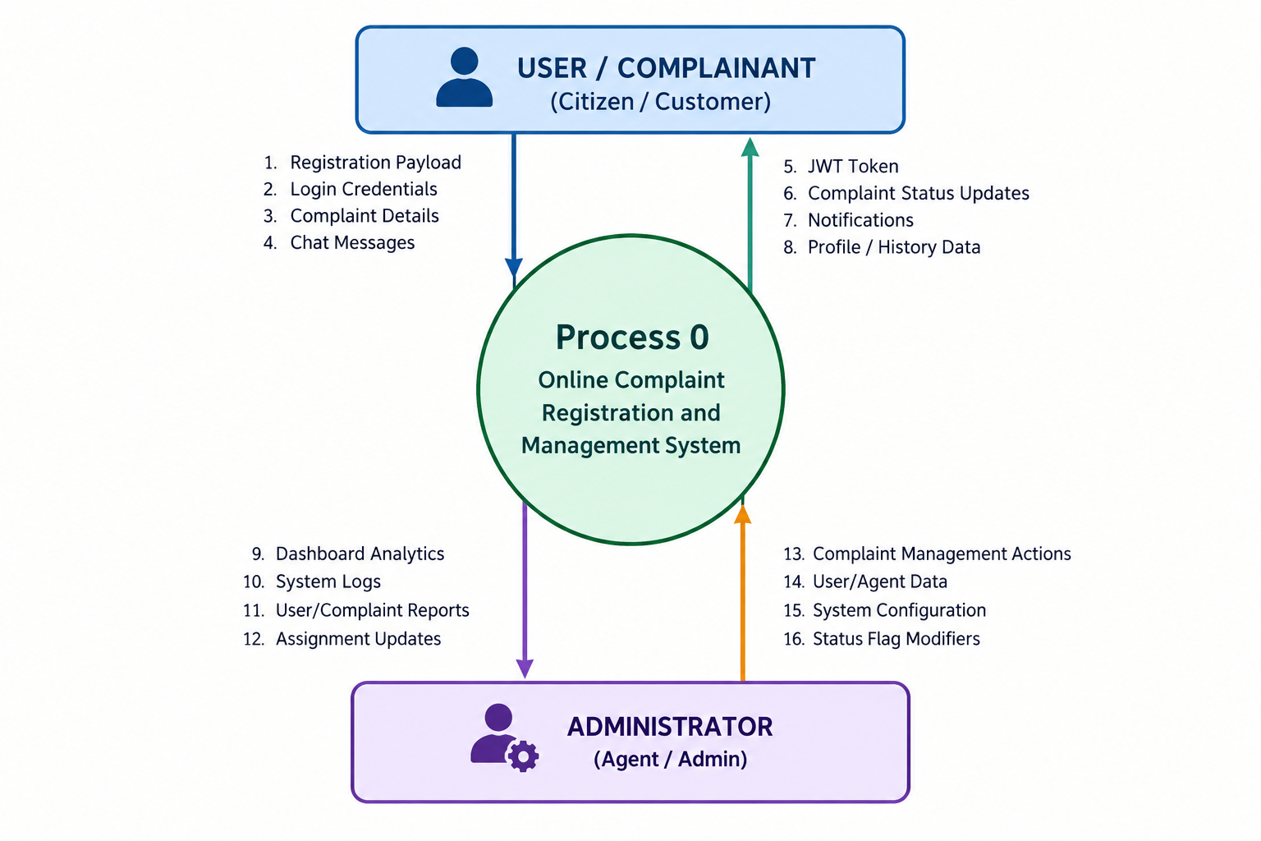

2. DFD Level 1: Operational Component Pipeline
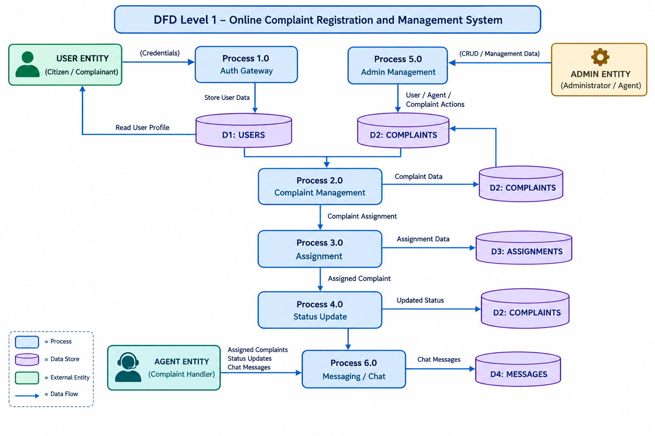
The optimized Level 1 structural representation decomposes the Online Complaint Registration and Management System into compact workflows covering user authentication, complaint registration and management, agent assignment, complaint status updates, admin management, and complaint-specific messaging using the MERN stack architecture.

3. Data Flow Diagram Entity and Process Dictionary
Element Identifier | Typology | Description & System Interactivity | Technology Mappings
User | External Entity | Registers and logs in, submits complaints, tracks complaint status, and communicates through complaint chat. | React Frontend
Agent | External Entity | Views assigned complaints, communicates with users, and updates complaint progress and status. | Agent Dashboard
Administrator | External Entity | Manages users and agents, views complaints, creates agents, and assigns complaints. | Admin Dashboard
Process 1.0 – Auth Gateway | System Process | Processes registration and login, validates credentials, generates JWT tokens, and applies role-based authorization. | Express.js + JWT Middleware
Process 2.0 – Complaint Management | System Process | Creates, retrieves, and manages complaint details and complaint status. | Express REST API + Mongoose
Process 3.0 – Assignment | System Process | Assigns complaints to agents and manages the complaint assignment workflow. | Express.js + MongoDB
Process 4.0 – Status Update | System Process | Updates complaint progress through controlled statuses such as Assigned, In Progress, Resolved, and Closed. | Node.js REST API
Process 5.0 – Admin Management | System Process | Allows administrators to manage users, agents, complaints, and complaint assignments. | Admin Protected Routes
Process 6.0 – Messaging / Chat | System Process | Allows authorized users and assigned agents to send and retrieve complaint-specific messages. | Express REST API + Mongoose
D1: Users Collection | Data Store | Stores user ID, name, email, phone, password hash, role, and account timestamps. | MongoDB + Mongoose User Model
D2: Complaints Collection | Data Store | Stores complaint ID, user reference, address, subject, description, status, resolution note, and timestamps. | MongoDB + Mongoose Complaint Model
D3: Assignments Collection | Data Store | Stores complaint-agent relationships, assigned agent, assigning administrator, status, and assignment time. | MongoDB + Mongoose Assignment Model
D4: Messages Collection | Data Store | Stores complaint reference, sender reference, message content, and message timestamps. | MongoDB + Mongoose Message Model

